## API Details

# <http://localhost:8080/getName>

<http://localhost:8080/getName?fName=suvendu&mName=kumar&lName=moharana>

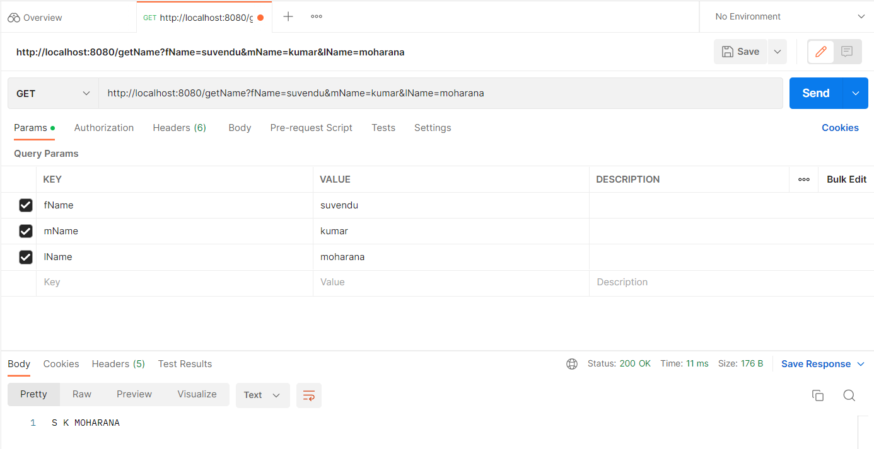

<http://localhost:8080/getName?fName=suvendu&mName=&lName=moharana>

